ASN.1 and BER 目录
The first Part: BER Standard 2
The Second Part: about Tags. Also the identifier (type or tag) 5
The Third Part: Some Keys in ASN.1 8
The Fourth Part: Practical examples. 9
The Fifth Part: DER 21
The Sixth Part: Reference 22
The Last one: Summary 22

============= Chapter 1: History ===========
(1) One fundamental distinction of Protocols is between:
## Character-based specification (Command-line or statement-based specification.)
## Binary specification
(Is binary specification (e.g., ASN.1) better than character-based specification (e.g., XML)?)
(Government Health Warning: This discussion can damage your health.)
(2) Simple encoding techniques were sufficient for simple applications such as “Telnet” and “Teletex” which transmit only textual data.
(3) With the advent of more complex applications, the need arose to pass structured information, suitable for program manipulation.
(4) For binary-based specification, approaches vary from various methods to use of a separately defined notation with associated application-independent encoding rules.
(5) Different groups define different notations and different sets of encoding rules.
(6) Need for application-independent notation (abstract syntax) and machine-independent encoding rules (transfer syntax).
(7) The idea of defining notation for abstract syntax and transfer syntax is normally credited to the Xerox Courier Specification, part of the XNS protocol suite.
(8) The notation used by Xerox Courier Specification was then developed into CCITT (now ITU-T) Recommendation X.409 (Presentation Transfer Syntax and Notation), part of X.400 (1984) series.
(9) In 1986, the notation and encoding rules in X.409 (1984) were accepted by ISO as the way to define OSI Application Layer and Presentation Layer protocols and rewritten as two separate documents:
## ISO 8824: Specification of Abstract Syntax Notation One (ASN.1)
## ISO 8825: Specification of Basic Encoding Rules (BER) for Abstract Syntax Notation One (ASN.1)
(10) Abstract Syntax Notation One was originally abbreviated as ASN1; But it was often got mistyped as ANS1 and then misread as ANSI (ansi); The resolution was the introduction of the "dot" into the abbreviation, so we now have "ASN.1".
(11) At about 1985/86, CCITT agreed to work with common text based on ISO 8824 and 8825.
CCITT finally withdrew X.409 and published:
## X.208 (1988) ASN.1 (identical to ISO 8824:1986 with some additions)
## X.209 (1988) BER (identical to ISO 8825:1986 with some additions)
In 1990, ISO and IEC jointly publish ISO/IEC 8824:1990 and ISO/IEC 8825:1990, which are identical to X.208 (1988) and X.209 (1988) with minor corrections.
(12) In 1994 (some said 1993),
ITU-T move ASN.1 and its related encoding rules specifications into ITU-T X.680-699 (ASN.1) series.
The current version including:
## X.680 (1997) | ISO/IEC 8824-1:1998 Abstract Syntax Notation One (ASN.1): Specification of basic notation
## X.681 (1997) | ISO/IEC 8824-2:1998 Abstract Syntax Notation One (ASN.1): Information object specification
## X.682 (1997) | ISO/IEC 8824-3:1998 Abstract Syntax Notation One (ASN.1): Constraint specification
## X.683 (1997) | ISO/IEC 8824-4:1998 Abstract Syntax Notation One (ASN.1): Parameterization of ASN.1 specification
## X.690 (1997) | ISO/IEC 8825-1:1998 ASN.1 encoding rules: Specification of Basic Encoding Rules (BER),
Canonical Encoding Rules (CER) and Distinguished Encoding Rules (DER)
## X.691 (1997) | ISO/IEC 8825-2:1998 ASN.1 encoding rules: Specification of Packed Encoding Rules (PER)
=================================
ISO Seven Layer Model
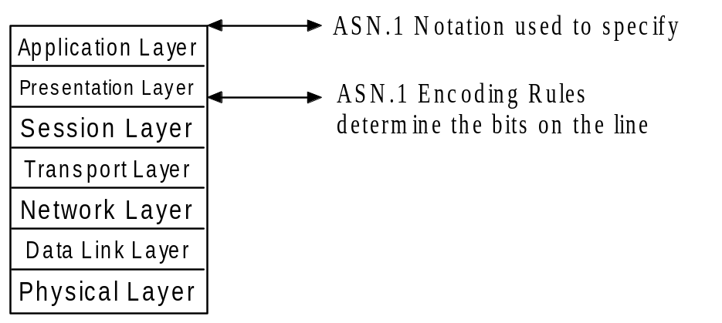

The first Part: BER Standard
ITU-T(X.690)和ISO(8825-1)标准
一种编码规格说明；描述如何将ASN.1类型的值编码成字节串(string of octets)的方法。
基于一种称为type-length-value (TLV)结构的方法，在ASN.1中，也称identifier-length-content(ILC)
Encode Principle:
BER, CER, DER and PER are sets of ASN.1 encoding rules.
A transfer value must unambiguously represent an abstract value.
The Basic Encoding Rules (BER) for ASN.1 gives one or more ways to represents any ASN.1 values as binary data.

BER 基本编码方法 编码形式
Identifier field | Length field | Contents field

I | L | C
Primitive encoded form
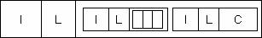
Constructed Encoded form

Important Notes: explain the three fields of ILC.
（1）The identifier including three fields: Tag, 1bits and Number (ID).
当tag Number值在0 ~ 30之间时，用低5位表示；
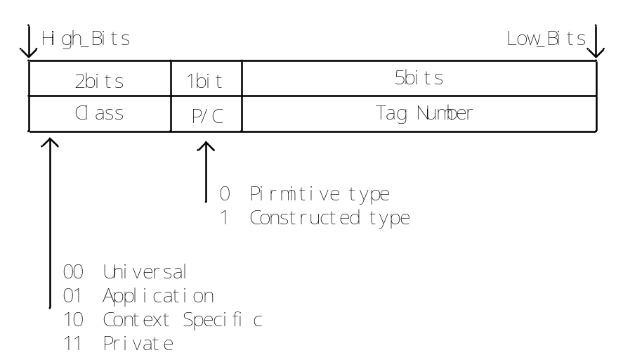
Fig: The first bytes of each data item sent in the ASN.1 transfer syntax.
当tag Number值大于30时，低5位为“11111”，用后面字节表示。每个标识字节包括7个数据位，最后一个字节高位为“0”，其它字节高位为“1”。
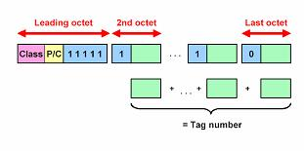
（2）the length of the data field, in bytes [注意：这儿是长度本身大于128bytes]
当长度字段 ＜ 128字节时，用一个字节表示长度，高位为“0”；
当长度字段 ≥ 128字节时，第一个字节高位为“1”，低7位表示后面表示长度的字节个数，后面的若干个（≤ 127）字节表示长度。
（低7位用来表示后面哪几个字节是用来标示长度的。）
例，数据长度1000字节，则长度域包括3个字节，第一个字节为“10000010”，后两个字节为“00000011”和“11101000”
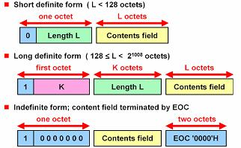
短格式: 既可用于基本类型，也可用于内容长度字段不超过128的构造类型.
长格式: 既可用于基本类型，也可用于构造类型；通常内容长度字段大于或等于128.
不定长格式：仅用于构造类型；EOC字节可看作是tag为0的基本类型，内容长度为0.
(Note: EOC = End of Contents. 2bytes = 0x0000 as the End Bytes.)
（3）the data field
INTEGER：二进制编码；（即：整数直接由二进制形式给出。）
BIT STRING：编码表示不变，长度域表示字节个数，并在传位串前先传一个字节表示位串最后一个字节不用的位数。
例，位串“010011111”传输时变为“07 4f 80”（十六进制）
OCTET STRING：编码表示不变；
NULL：长度域为0，不传数据；
OBJECT IDENTIFIER：按照命名树的编码整数序列编码，前两个数a, b可用一个字节编码，值为40a + b
如果数据长度未知，需要有结束标志。

The Second Part: about Tags. Also the identifier (type or tag)
The key is: ASN.1 syntax relation with the Encode/Decode.
- Every ASN.1 type has a tag, which consists of a class and a nonnegative tag number.
- 标签有四类：universal, application-wide, context-specific, private
[A class, in the context of the abstract syntax or transfer syntax, is a one of four possible domains for uniquely defining a type. The classes defined by ASN.1 and BER are: UNIVERSAL, APPLICATION, CONTEXT, and PRIVATE.]
Universal | For types whose meaning is the same in all applications.  The UNIVERSAL class is reserved for international standards such as [33] and [34].
Application | For types whose meaning is specific to an application.  APPLICATION class parameters are reserved for future extensions.
Context-specific | for types whose meaning is specific to a given structured type
Private | for types whose meaning is specific to an given enterprise  Users of the protocol may extend the syntax with PRIVATE class parameters, but risk conflict with other users' extensions.
- The header of MODULE may indicate one of the following three tagging environment
Implicitly tagging (IMPLICIT TAGS)
Explicitly tagging (EXPLICIT TAGS)
Automatic tagging (AUTOMATIC TAGS) (ASN.1:1994)
Omission of all of these implies an environment of explicit tagging. (Why? Because before 1988 the only available tagging is explicit tagging.)
In the BER a tag (a particular type and class identifier) may either be a primitive or a constructor.
A primitive is a pre-defined type (of class UNIVERSAL) and a constructor consists of other types (primitives or other constructors).
A constructor type may either be IMPLICIT or EXPLICIT.
An IMPLICIT type is encoded with the constructor identifier alone. Both ends of a communication must understand the underlying structure of the IMPLICIT types. EXPLICIT types are encoded with the identifiers of all the contained types. For example, an IMPLICIT Number of types INTEGER would be tagged only with the Number tag, where an EXPLICIT number of types INTEGER would have the INTEGER tag within the Number tag.
说明：primitive = BOOLEAN/INTEGER/ENUM/REAL;
Construct : SEQ, SEQ OF, SET, SET OF;
Primitive/Construct：Printable String, BIT STRING, OCTET STRING...
- Primitive, definite-length method
Applies to simple types , and types derived from simple types by implicit tagging.
- Constructed, definite-length method
Applies to simple string types, structured types, types derived from simple string types, structured typed by implicit tagging, and type derived from anything by explicit tagging.
- Constructed, indefinite-length method
applies to simple string types, structured types, types derived from simple string types, and structured types by implicit tagging, and types derived from anything by explicit tagging.
- There is NO Primitive, indefinite-length method!
ASN.1描述与编码的对应关系： IMPLICIT Key
- If the “IMPLICIT” keyword was not used in the definition of the type, the encoding shall be constructed, and the contents octets shall be the complete base encoding.
- If the “IMPLICIT” keyword was used in the definition of the type, then
  - the encoding shall be constructed if the base encoding is constructed, and shall be primitive otherwise; and
  - The contents shall be the same as the contents octets of the base encoding.
- The ASN.1 notation to specified user-define tag on a type
- [[class]number] CHOICE {...} always ===> explicit
- [[class] number] IMPLICIT CHOICE {……} is illegal.
- [[class]number] [IMPLICIT|EXPLICIT] TYPE.
where class = UNIVERSAL|APPLICATION|PRIVATE
If the class name is absent, the tag is context-specific.
- Users are not allowed to assign UNIVERSAL tags.

Universal class tags:
Primitive Type | Meaning | Code
BOOLEAN |  | 1/0x01
INTEGER | Arbitary length integer | 2/0x02 | all negative and positive integers
BIT STRING | A string of 0 or more bits | 3/0x03
OCTET STRING | A string of 0 or more unsigned bytes | 4/0x04
NULL | A place holder | 5/0x05 | Denotes a null value.
OBJECT IDENTIFIER | An officially defined data type | 6/0x06 | Denote an object identifier, a sequence of integer components that identifies an object such as an algorithm, an attribute type, or perhaps a registration authority that defines other object identifiers. An OBJECT IDENTIFER value can have any value of components, and components can generally have any nonnegative value.
Object Descriptor |  | 7/0x07
REAL |  | 9/0x09
ENUMERATED |  | 10/0x0a
SEQUENCE[OF] |  | 16/0x10
SET[OF] |  | 17/0x11
IA5String |  | 22/0x16
UTCTime |  | 23/0x17 | yy = 50..99 ; 1950-1999  yy = 00..49; 2000-2049
GeneralizedTime |  | 24/0x18 | Mandatory starting with the year 2050
VisibleString |  | 26/0x1a
NumericString, PrintableString, IA5String, VisibleString, TeletexString, VideotexString, GraphicString, GeneralString… | Character string type | 18 - 22  25 - 30

几种string的解释：
NumericString |  | PrintableString
Name | Graphic | Name | Graphic
Digits Space | 0, 1,…, 9  (space) | Capital letters  Small letters  Digits  Space  Apostrophe  Left Parenthesis  Right Parenthesis  Plus sign  Comma  Hyphen  Full stop  Solidus  Colon  Equal sign  Question mark | A,B, …, Z  a, b, …, z  0, 1, …, 9  (space)  '  (  )  +  ,  -  .  /  :  =  ?

VisibleString | - Pre-1986, it was called ISO646String (now deprecated)  - Contains characters with ASCII code from 32 to 126
IA5String | - Original reference is “International Alphabet 5”  - Contains characters with ASCII code from 0 to 127 (7-bit ASCII)
TeletexString (T61String) | - Original reference is CCITT Recommendation T.61  - Now maintain alignment to the ITU-T Teletex Recommendations  - Uses ASCII ESCAPE codes to switch between character sets for different languages such Japanese, Korean, Greek, …
UniversalString | (ASN.1:1994) ISO/IEC 10646-1 UCS-4 character set
BMPString | (ASN.1:1997) ISO/IEC 10646-1 Basic Multi-lingual Plane
UTF8String | (ASN.1:1997) UTF-8 encoded ISO/IEC 10646-1 UCS-4 char.

The Third Part: Some Keys in ASN.1
ASN.1 Structured Type 部分类型的说明：
SEQUENCE | an ordered collection of one or more types
SEQUENCE OF | an ordered collection of zero or more occurrences of a given type
SET | an unordered collection of one or more types
SET OF | an unordered collection of zero or more occurrences of a given type
CHOICE | an union of one or more alternative

Some Key explains:
OPTIONAL | The fields in a SEQUENCE or SET can be marked OPTIONAL, in which they may be present or absent in a message.
DEFAULT | The fields in a SEQUENCE or SET can be marked DEFAULT, following be a value for the datatype of the fields. For example, “INTEGER DEFAULT 3” states that if this field is missing, the meaning is exactly the same as if it were present with the value 3.

Some Comments:
- ASN.1 is designed for telecommunications:
Use of variable length encodings:
Arbitrary precision INTEGERs,
Arbitrary range and precision REALs,
Variable length STRINGs,
Variable length SEQUENCEs.
- Use of unordered SETs,
- Optional components within structures,
- Abstract Syntax include specification of TAGs.
Direct mapping to “C” (or other programming languages) structures is almost impossible.

The Fourth Part: Practical examples.
Some ASN.1 Descriptions:
ASN.1 Type Definitions
Syntax: <type name> ::= <type>
Examples:
Counter ::= INTEGER
IpAddress ::= OCTET STRING
Months ::= ENUMERATED {january (1),
february (2),
march (3),
april (4),
may (5),
june (6),
july (7),
august (8),
september (9),
october (10),
november (11),
december (12)}
ASN.1 Subtype Definitions
Syntax: <subtype name> ::= <type> ( <constraint> )
Examples:
Counter ::= INTEGER ( 0..4294967295 )
IpAddress ::= OCTET STRING ( SIZE(4) )
Spring ::= Months ( march | april | may )
Summer ::= Months ( june | july | august )
SmallPrime ::= INTEGER ( 2 | 3 | 5 | 7 | 11 )
ExportKey ::= BIT STRING ( SIZE(40) )
ASN.1 Value Assignments I
Syntax: <value name> <type> ::= <value>
Examples:
ipInReceives Counter ::= 2450
ipRouteMask IpAddress ::= 'FFFFFF00'H
currentMonth Months ::= february
currentTime UTCTime ::= "000204075015+0100"
givenName VisibleString ::= "Andreas"
married BOOLEAN ::= TRUE
faxMessage BIT STRING ::= '01100001101'B
encryptionKey ExportKey ::= 'A1B2C3D4E5'H
ASN.1 Value Assignments II OBJECT IDENTIFIER
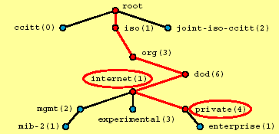
internet OBJECT IDENTIFIER ::= { iso(1) org(3) dod(6) 1 }
private OBJECT IDENTIFIER ::= { internet 4 }
Hierarchical Tree Structure
• ASN.1 object identifiers are organized in a hierarchical tree structure to make it possible to give any object a unique global identifier.
SNMP Objects
• The official SNMP objects defined by various RFCs are attached below the node
{ iso(1) org(3) dod( 6) internet(2) mgmt(1) }
• Enterprise specific SNMP objects are attached below the node
{ iso(1) org(3) dod( 6) internet(2) private(4) enterprise(1) }

SNMP OIDs of some well-known enterprises
• IBM: { enterprises 2 }
• Cisco: { enterprises 9 }
• Hewlett-Packard: { enterprises 11 }
• Sun Microsystems: { enterprises 42 }
• Microsoft: { enterprises 311 }
• Intel: { enterprises 343 }

Security OIDs of some well-known enterprises
• Sun Microsystems: { iso(1) member-body(2) US(840) 113536 }
• RSA Data Security Inc: { iso(1) member-body(2) US(840) 113549 }
• Microsoft: { iso(1) member-body(2) US(840) 113556 }
• Netscape: { joint-iso-ccitt (2) country (16) usa (840) org (1) 113730 }
• Verisign: { joint-iso-ccitt (2) country (16) usa (840) org (1) 113733 }
• Intel: { joint-iso-ccitt (2) country (16) usa (840) org (1) 113741 }
ASN.1 Structured Types I SEQUENCE
Use: Collection of a moderate number of variables that may be of different type and whose order is significant.
Type Definition: UserAccount ::= SEQUENCE {
username VisibleString,
password VisibleString,
accountNr INTEGER
}
Value Assignment: myAccount UserAccount ::= {
username "steffen",
password "jane51",
accountNr 4711
}
ASN.1 Structured Types II SEQUENCE OF
Use: Collection of a large number of variables of the same type and whose order is significant.
Type Definition:
MemberCountries ::= SEQUENCE OF VisibleString
AccountRegistry ::= SEQUENCE OF UserAccount
Value Assignment:
euMembers MemberCountries ::= {
"Austria", "Belgium", "Denmark",
"Finland", "France", "Germany",
"Greece", "Ireland", "Italy",
"Luxembourg", "The Netherlands",
"Portugal", "Spain", "Sweden",
"United Kingdom"}
ASN.1 Structured Types III SET
Use: Collection of a moderate number of variables that may be of different type and whose order is insignificant.
Type Definition: UserAccount ::= SET {
username [0] VisibleString,
password [1] VisibleString, // context-specific tags or automatic tagging
accountNr [2] INTEGER
}
Value Assignment: myAccount UserAccount ::= {
accountNr 4711,
username "steffen",
password "jane51"
}
Context-Specific Tags
• Since they can occur in arbitrary order, the members of a set need tags in order to uniquely identify them. Tags can either be defined explicitly by the system designer or are assigned automatically by the ASN.1 parser if the automatic tagging option is used.
ASN.1 Structured Types IV SET OF
Use: Collection of variables that are the same type and whose order is insignificant.
Type Definition: Keywords ::= SET OF VisibleString
Value Assignment:
someASN1Keywords Keywords ::= {"INTEGER", "BOOLEAN", "REAL"}
# Example of ASN.1 Specification
Sample-Module {joint-iso-itu-t(2) country(16) taiwan(886) cht(1) asn1-modules(999) sample1(1) }
DEFINITIONS
EXPLICIT TAGS ::=
BEGIN
PersonnelRecord ::= [APPLICATION 0] IMPLICIT SET {
name Name,
title [0] VisibleString,
number EmployeeNumber,
dateOfHire [1] Date,
nameOfSpouse [2] Name,
children [3] IMPLICIT SEQUENCE OF
ChildInformation DEFAULT {} }
ChildrenInformation ::= SET {
name Name,
dateOfBirth [0] Date}

Name ::= [APPLICATION 1] IMPLICIT SEQUENCE {
givenName VisibleString,
initial VisibleString,
familyName VisibleString}

EmployeeNumber ::= [APPLICATION 2] IMPLICIT INTEGER

Date ::= [APPLICATION 3] IMPLICIT VisibleString
--YYYYMMDD
END
# Value Notation
recordOfJohnSmith PersonnelRecord ::= {
name {givenName “John”, initial “P”, familyName “Smith”},
title “Director”,
number 51,
dateOfHire “19710917”,
nameOfSpouse {givenName “Mary”, initial “T”, familyName “smith”},
children {
{{givenName “Ralph”, initial “T”, familyName “Smith”},
dateOfBirth “19571111”},
{{givenName “Susan”,initial “B”, familyName “Jones”},
dateOfBirth “19590717”}
}
}
# Example of Subtype
AtomicNumber ::= INTEGER (1..104)
PositiveInteger ::= INTEGER (1..MAX)
My-string1 ::= PrintableString (SIZE (1..10)) (FROM (“A”..”Z”))
My-string2 ::= PrintableString (SIZE (1..10) INTERSECTION FROM (“A”..”Z”))
AnswerString ::= PrintableString (“Yes” | “No”)
My-string3 ::= PrintableString (SIZE (1..10) INTERSECTION FROM (“A”..”Z”)
UNION AnswerString EXCEPT “YES” UNION “NO”)
My-string4 ::= PrintableString (SIZE(1..10) ^ FROM (“A”..”Z”) | AnswerString
EXCEPT “YES” | “NO”)
SmallPrime ::= INTEGER(2 | 3 | 5 | 7, …)
String-of-vowels1 ::= PrintableString (FROM (“AEIOU”))
String-of-vowels2 ::= PrintableString (FROM (“AEIOU” UNION “aeiou”))
My-Sequence ::= SEQUENCE (SIZE (10)) OF PrintableString
My-Sequence ::= SEQUENCE (SIZE (1..10)) OF PrintableString (SIZE (0..15))
Envelope ::= SET {
typeA TypeA,
typeB TypeB OPTIONAL,
typeC TypeC OPTIONAL}
ABEnvelope1 ::= Envelope (WITH COMPONENTS
{…, typeB PRESENT, typeC ABSENT})
ABEnvelop2 ::= Envelope (WITH COMPONENTS {typeA, typeB})
AuthorityKeyIdentifier ::= SEQUENCE {
keyIdentifier [0] KeyIdentifier OPTIONAL,
authorityCertIssuer [1] GeneralNames OPTIONAL,
authorityCertSerialNumber [2] CertificateSerialNumber OPTIONAL }
( WITH COMPONENTS {..., authorityCertIssuer PRESENT,
authorityCertSerialNumber PRESENT} |
WITH COMPONENTS {..., authorityCertIssuer ABSENT,
authorityCertSerialNumber ABSENT} )
# Example of Constraint
User-defined constraint
ENCRYPTED {ToBeEnciphered} ::= BIT STRING
(CONSTRAINED BY
{-- must be the result of the encipherment of --
-- some BER-encoded value of -- ToBeEnciphered}
! Error: securityViolation)
Error ::= ENUMERATED {securityViolation}
# Example of Object Information Class + Constraint
SubjectPublicKeyInfo ::= SEQUENCE {
algorithm AlgorithmIdentifier,
subjectPublicKey BIT STRING }

ALGORITHM-ID ::= TYPE-IDENTIFIER

AlgorithmIdentifier ::= SEQUENCE {
algorithm ALGORITHM-ID.&id
({SupportedAlgorithms}),
parameters ALGORITHM-ID.&Type
({SupportedAlgorithms} {@algorithm}) OPTIONAL }

-- Defined in X.681 --
TYPE-IDENTIFIER ::= CLASS
{
&id OBJECT IDENTIFIER UNIQUE,
&Type
}
WITH SYNTAX {&Type IDENTIFIED BY &id}

SupportedAlgorithms ALGORITHM-ID ::= {…, rsaPublicKey | dsaPublicKey | dhPublicKey}
rsaPublicKey ALGORITHM-ID ::= { NULL IDENTIFIED BY rsaEncryption}
dsaPublicKey ALGORITHM-ID ::= { Dss-Parms IDENTIFIED BY id-dsa}
dhPublicKey ALGORITHM-ID ::= { DomainParameters IDENTIFIED BY dhpublicnumber}

Table of SupportedSignatureAlgorithms
&id | &Type
rsaEncryption | NULL
id-dsa | Dss-Parms
dhpublicnumber | DomainParameters

# Example of Parameterization + Constraint
ENCRYPTED-HASH { ToBeSigned } ::= BIT STRING ( CONSTRAINED BY {
-- must be the result of applying a hashing --
-- procedure to the DER-encoded (see 8.7) --
-- octets of a value of -- ToBeSigned -- and then --
-- applying an encipherment procedure to those octets -- })

ENCRYPTED { ToBeEnciphered } ::= BIT STRING ( CONSTRAINED BY {
-- must be the result of applying an encipherment procedure --
-- to the BER-encoded octets of a value of -- ToBeEnciphered})

SIGNATURE { ToBeSigned } ::= SEQUENCE {
algorithmIdentifier AlgorithmIdentifier,
encrypted ENCRYPTED-HASH { ToBeSigned }}

SIGNED { ToBeSigned } ::= SEQUENCE {
toBeSigned ToBeSigned,
COMPONENTS OF SIGNATURE { ToBeSigned }}
Explicit Tagging: (strong type checking)
IpAddress ::= [APPLICATION 0] OCTET STRING (SIZE(4))
Counter ::= [APPLICATION 1] INTEGER (0..4294967295)
Implicit Tagging: (shorter encoding)
IpAddress ::= [APPLICATION 0] IMPLICIT OCTET STRING (SIZE(4))
Counter ::= [APPLICATION 1] IMPLICIT INTEGER (0..4294967295)

Encode/Decode Example:
# Example 1
Example - If of type
SEQUENCE{name IA5String, ok BOOLEAN}
the value {name "Smith", ok TRUE}
can be encoded as

Sequence Length Contents
0x30 0x0a
IA5String Length Contents
0x16 0x05 Smith
Boolean Length Contents
0x01 0x01 0xff
# Example 2
Type1 ::= VisibleString
Type2 ::= [APLICATION 3] IMPLICIT Type1
Type3 ::= [2] Type2
Type4 ::= [APLICATION 7] IMPLICIT Type2
Type5 ::= [2] IMPLICIT Type2
A value of “Jones” is encoding as follows:

For Type1:
VisibleString Length Contents
0x1a 0x05 0x4a6f6e6573

For Type2:
[APPLICATION 3] Length Contents
0x43 0x05 0x4a6f6e6573

For Type3:
[2] Length Contents
0xa2 0x07
[APPLICATION 3] Length Contents
0x43 0x05 0x4a6f6e6573

For Type4:
[APPLICATION 7] Length Contents
0x67 0x07
[APPLICATION 3] Length Contents
0x43 0x05 0x4a6f6e6573

For Type5: (这个编码是不是有些问题)
[2] Length Contents
0x82 0x05 0x4a6f6e6573
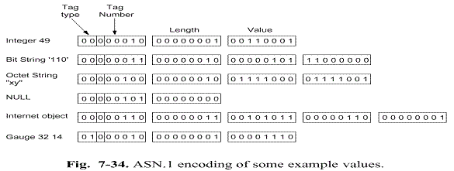
Integer:
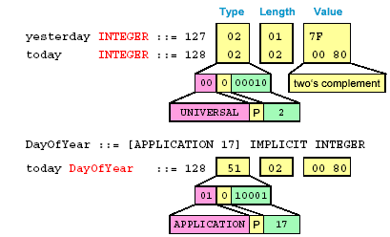
BER coding for two's complement integers:
-129: 1111 1111 0111 1111 = 02 02 FF 7F
-128: 1111 1111 1000 0000 = 02 01 80
-127: 1111 1111 1000 0001 = 02 01 81
-1: 1111 1111 1111 1111 = 02 01 FF
0: 0000 0000 0000 0000 = 02 00
1: 0000 0000 0111 1111 = 02 01 01
127: 0000 0000 0111 1111 = 02 01 7F
128: 0000 0000 1000 0000 = 02 02 00 80
129: 0000 0000 1000 0001 = 02 02 00 81
SEQUENCE:
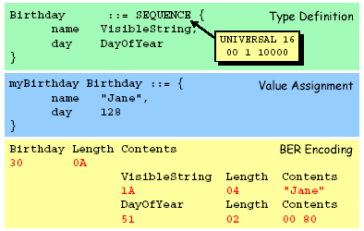
Encoding of an object identifier (OID) value
  - The content octets is a list of encodings of subidentifier concatenated togather;
  - The method of encodings of each subidentifier is the same as the method of encoding a tag number in High-Tag-Number Form
  - First subidentifier =(X*40)+Y
  - where X is the value of the first OID component and Y is
  - The value of the second OID component.
Example:

An OID value of {joint-iso-ccitt 100 3} which is the same as {2 100 3} has a first subidentifier of 180 and a second subidentifier of 3. The resulting encoding is
OID Length Contents
0x06 0x03 0x813403

OBJECT INDENTIFIER
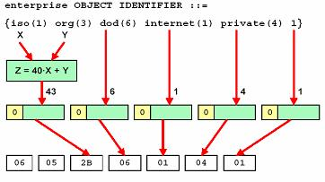
Coding of OID Root
ccitt(0): Z = Y {0..39}
iso(1): Z = 40 + Y {40..79}
joint-iso-ccitt(2): Z = 80 + Y {80..119}
Coding of OID nude numbers
类似于Identifier字段中的Tag编码:每个标识字节包括7个数据位，最后一个字节高位为“0”，其它字节高位为“1”。
Range {0..127}: 0XXX XXXX
Range {128..16383}: 1XXX XXXX 0XXX XXXX
Range {16384..2097151}: 1XXX XXXX 1XXX XXXX 0XXX XXXX
例：RSA数据安全公司 {1 2 840 113549}
06 06 2a 86 48 86 f7 0d
The encoding of INSTANCE OF

INSTANCE OF <DefinedObjectClass>

is equivalent to

[UNIVERSAL 8] IMPLICIT SEQUENCE
{
type-id <DefinedObjectClass>.&id,
value [0] EXPLICIT <DefinedObjectClass>.&Type
}

The Fifth Part: DER
BER编码存在的问题
不唯一 : 同一个值可能有超过1种合法的编码; 灵活,但容易造成混淆
示例 :
BIT STRING值 01101110 01011101 11
BIT STRING编码中,在长度字段后的第一个字节给出了最后一个字节中未用到的位数(本例中为6)
03 04 06 6e 5d c0 (用0填充,短格式)
03 04 06 6e 5d e0 (用100000填充)
03 81 04 06 6e 5d e0 (长格式)
23 09 (构造式编码)
03 03 00 6e 5d (“0110111001011101”+”11”)
03 02 06 c0
解决方案(两种方向)
DER: BER子集,只使用定长编码
CER: BER子集,基于不定长编码

DER: distinguished encoding rules
Subset of BER gives exactly one way to represent any ASN.1 value. Used e.g. in X.509 certificates where computation of digital hash sums must be unique. It Uses definite-length encoding.
BER的子集,增加某些限制
DER附加规则
当长度在0到127之间时,长度字段必须使用短格式
当长度是128或者更长时,长度字段必须使用长格式,同时长度必须以最小数目的八位组来编码
对于从简单字符串类型衍生出来的简单字符串类型和隐式标记类型,必须使用基本的定长方法
对于结构类型、从结构类型衍生出来的隐式标记类型，以及从任何类型衍生出来的显式标记类型，必须使用构造的定长方法
对于特殊类型,另有限制
BIT STRING: 必须用0填充
SEQUENCE [OF]中的OPTIONAL和DEFAULT限定符
SET [OF]除同SEQUENCE相同的规定外，各分量要求以标记的升序排列

DER is the BER with the following restrictions:
a) The definite form of length encoding shall be used, encoded in the minimum number of octets;
b) For string types, the constructed form of encoding shall not be used;
c) If the value of a type is its default value, it shall be absent;
d) The components of a SET type shall be encoded in ascending order of their tag value;
e) The components of a SET OF type shall be encoded in ascending order of their octet value;
f) If the value of a BOOLEAN type is true, the encoding shall have its contents octet set to “0xff”;
g) Each unused bits in the final octet of the encoding of a BIT STRING value, if there are any, shall be set to zero;
h) The encoding of a REAL type shall be such that bases 8, 10, and 16 shall not be used, and the binary scaling factor shall be zero.

DER: distinguished encoding rules
Subset of BER gives exactly one way to represent any ASN.1 value. Used e.g. in X.509 certificates where computation of digital hash sums must be unique. It Uses definite-length encoding.

Packed Encoding Rules (PER)
Very compressed encoding based on ASN.1 subtype information. Example: subtype INTEGER (998...1001) is encoded using two bits only. Used e.g. in H.323 multimedia standard.

Canonical Encoding Rules (CER)
Subset of BER gives exactly one way to represent any ASN.1 value but based on indefinite-length encoding.

The Sixth Part: Reference
Reference:
[33] ITU-T Recommendation X.680: "Information technology - Abstract Syntax Notation One (ASN.1): Specification of basic notation".
[34] ITU-T Recommendation X.690: "Information technology - ASN.1 encoding rules: Specification of Basic Encoding Rules (BER), Canonical Encoding Rules (CER) and Distinguished Encoding Rules (DER)".

The Last one: Summary
From abstract specification to bits-on-the-line
